Duncan, Sara Jeannette (Cotes) 1861-1922.

Thumbnail:

Sara Jeannette Duncan was the first modern novelist in Canada. Author of twenty-two books of fiction, many of them international best-sellers, she was born in the small industrial town of Brantford Ontario, and later lived in Calcutta, Simla and London. Her work is known for championing the cosmopolitan life of the artist and political idealist in contrast to small-mindedness she identified as characteristic equally of British, Canadian, and Anglo-Indian society. While her early novels were light-hearted best sellers characterized by ironic narration and domestic detail, her later works experimented with point of view and style in a manner influenced by Henry James, like him exploring issues of personal integrity and artistic judgment but often in a colonial context.

Main entry:

Duncan began her career as a writer by publishing freelance poetry and articles with local newspapers, later joining the editorial staff of the Toronto *Globe*, the *Washington Post* and the *Montreal Star*. In these early columns and news articles she explored the topics that would become important to her fiction, including contemporary realism, prose style, and women’s education and career opportunities. Her first novel, a fictionalized account of a trip around the world with fellow journalist Lily Lewis, was published in 1890 by Chatto in London. Her marriage in the same year to Everard Charles Cotes, an entomologist employed by the Indian Museum in Calcutta, was the cause of her relocation to India, where she was based first in Calcutta and later in Simla, with regular trips to London (where her publishers were based) and to visit family in Canada.

Duncan’s early fiction continues the strengths of her journalism – close observation, description of manners, and wry humour.  *A Social Departure* (1890) was followed immediately by *An American Girl in London* (1891) and *The Simple Adventures of a Memsahib* (1893); all three rely on the trope of a travelling outsider to create comedic clashes of manners and attitudes. These early successes were popular and commercial, full of ironic humour and some slapstick comedy: another early novel, *Vernon’s Aunt* (1894) was serialized in Robert Barr’s comic paper *The Idler*. She continued to write this kind of commercial fiction throughout her career, sometimes under pseudonyms (such as Jane Wintergreen and V. Cecil Cotes). Duncan’s first serious novel, *A Daughter of To-day* (1894), addresses the theme of the “new woman” in the character of Elfrida Bell, an aspiring artist who champions the French Naturalists and writes a book based on her experiences as a burlesque dancer. *A Daughter of To-day* inaugurates Duncan’s move into the more serious themes that characterize the rest of her career: the relative importance of morality and aesthetic expression; the relationship between personal integrity and public duty; and the structure of imperial-colonial power in the dying days of the British Empire. *Set in Authority* (1906) fictionalizes an important political crisis in the British Raj: *The Burnt Offering* (1910) discusses a violent nationalist insurrection in India. Her best known novel, *The Imperialist* (1904), is also the only novel she set in Canada: it follows the career of an idealistic young Canadian who visits England only to discover it is governed by the same provincialism and middle-class insularity that limits Canadian politics.

Duncan’s professional ambition was noticeable from the beginning of her career, when she interviewed prominent women about their working lives for her columns in the Toronto *Globe.* While never a joiner, she advocated for feminist causes such as the vote as early as 1884, advised women not to use diminutive names in their professional lives, and argued for the seriousness and importance of women in fiction. Her later novels represent women who struggle to define themselves as individuals in the context of heterosexual love: *The Path of a Star* (1898) features an actress who recognizes that marriage will limit her career prospects, and a missionary who betrays her commitment to helping Indian women to become the conventional wife of a civil servant. In *The Pool in the Desert* (1902), a collection of short fiction, the main characters search for a romantic partner who will constitute an oasis of sensitivity and intellectual discernment among the bluff, self-satisfied members of the British Raj. *Cousin Cinderella* (1908), perhaps her most successful blending of ironic humour and more serious political themes, depicts a Canadian heroine whose happy engagement to an impoverished British lord allegorically represents a political rapprochement between Britain and her colonies.

Duncan’s early style was strongly influenced by her admiration for W. D. Howells, and she identified the realist representation of a colonial setting, whether in Canada or India, with stylistic innovation. Despite her critical eye and sharp wit, Duncan came to identify herself with the Anglo-Indians of the Raj, possibly because they shared with Canadians a sense of their marginality within the British empire, and similarly lacked any appreciation of their privilege in it. Her Canadian upbringing and adulthood in India made her sympathetic to the problems of representing the perspectives of the colonized, with the result that her novels foreground the issue of point of view. Her later work experimented with the structure of the sentence, indulging in long periods and convoluted subordinate clauses in a way often deplored by reviewers who admired her early work. Her narrative voice is self-conscious and ironic, subverting reader expectations and commenting on plot structure in order to call attention to its artificiality. She played hostess to E. M. Forster when he visited Simla in 1912, and her description of Simla as “Pilaghur” in *Set in Authority* almost certainly inspired the famous opening description of Chandrapore in *A Passage to India*.

Works:

*A Social Departure: How Orthodocia and I Went Round The World by Ourselves*. (1890)

*Two Girls on a Barge* (1891) as V. Cecil Cotes

*An American Girl in London* (1891)

*The Simple Adventures of a Memsahib* (1893)

*A Daughter of To-day* (1894)

*Vernon's Aunt: Being the Oriental Experiences of Miss Lavinia Moffat* (1894)

*The Story of Sonny Sahib* (1894)

*His Honour and a Lady* (1896)

*A Voyage of Consolation* (being in the nature of a sequel to the experiences of 'An American Girl in London') (1897)

*Hilda: A Story of Calcutta* (1898) also published as *The Path of a Star*.

*The Crow's Nest* (1901) also published as *On the Other Side of the Latch* (1901)

*Those Delightful Americans* (1902)

*The Pool in the Desert* (1903)

*The Imperialist* (1904)

*Set in Authority* (1906)

*Cousin Cinderella* (1908)

*Two in a Flat* (1908) as Jane Wintergreen

*The Burnt Offering* (1909)

*The Consort* (1912)

*His Royal Happiness* (1914)

*Title Clear* (1922)

*The Gold Cure* (1924)

Further Reading

Dean, Misao. “Introduction” *The Imperialist* by Sara Jeannette Duncan. Broadview, 2005.

Willmott, Glenn. *Unreal Country*, McGill-Queens UP 2002.

Paratextual stuff:

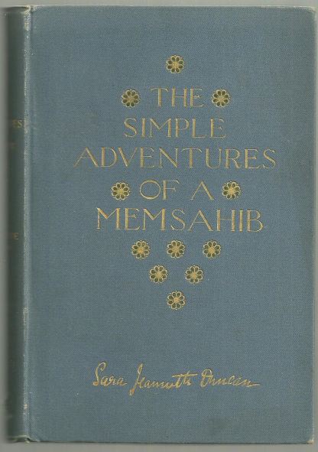

cover of The Simple Adventures of a Memsahib, 1893

[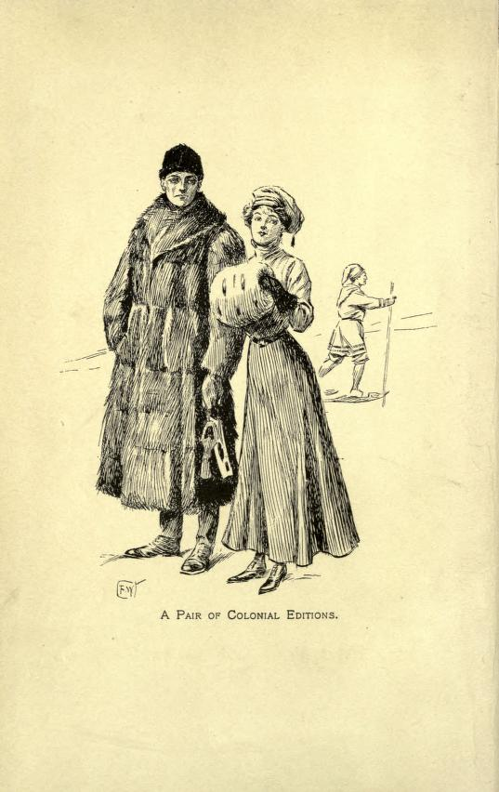](https://archive.org/stream/typesofcanadianw01morguoft#page/n7/mode/2up)

Frontispiece from Cousin Cinderella (1908) representing the protagonists before their trip to London as unsophisticated Canadians.

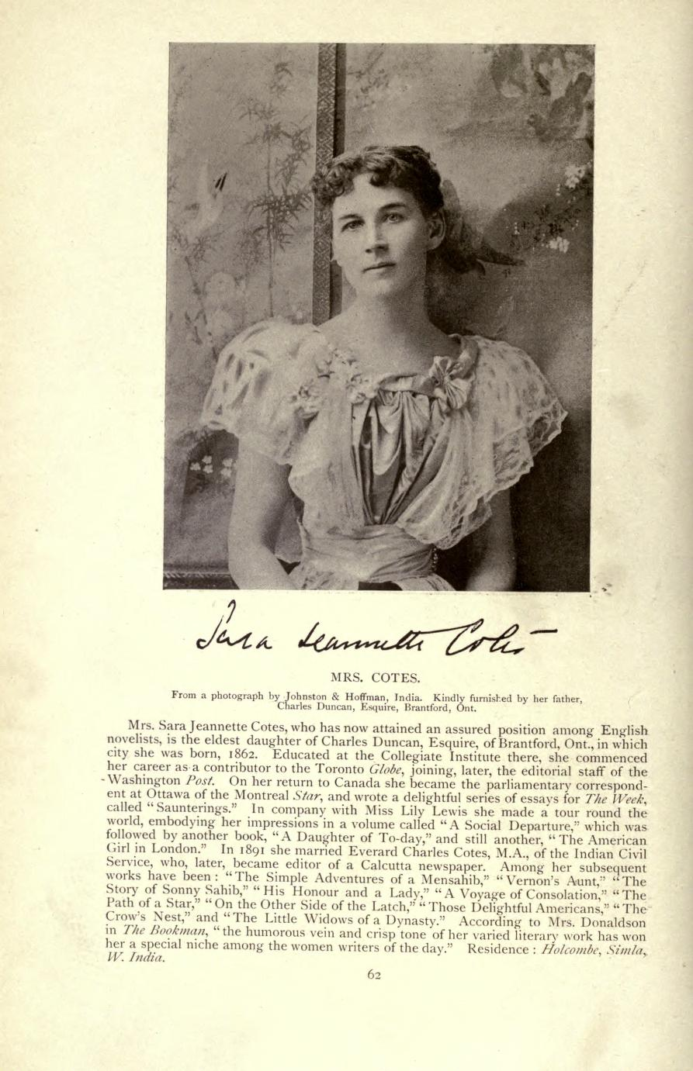

Biography of Duncan in Morgan’s *Types of Canadian Women* (Briggs 1903) (public domain)

https://archive.org/stream/typesofcanadianw01morguoft#page/n7/mode/2up